

Quality and
Environmental Policy

Ecotile Flooring Ltd is the UK’s premiere flooring solutions company. A world leader in the manufacture, supply and installation of interlocking floor tiles.

Quality is the foundation on which ‘Ecotile’ is based. Our commitment to quality products and service stems from our desire to achieve business excellence and strive to give our customers the highest standard of products and services that we deliver. Our aim being to ensure total satisfaction for the customers.

Every employee in the Company is a responsible member of our team, and is expected to ensure the products and services that we supply conform to our high standards and our customers requirements.

Ecotile regularly assess the environmental impacts of its activities and from these results sets annual objectives and targets to reduce the environmental footprint of the company.

We have systems and procedures in place to ensure the protection of the environment, including prevention of pollution and to minimise waste and the use of natural resources.

To ensure compliance with customer, statutory, environmental and regulatory requirements, the policy, objectives and management systems are reviewed by the management for their suitability, effectiveness, customer satisfaction and to ensure continual improvement.

Signed . . . . Michael Ollivere. . . . . . . Michael Ollivere
Managing Director

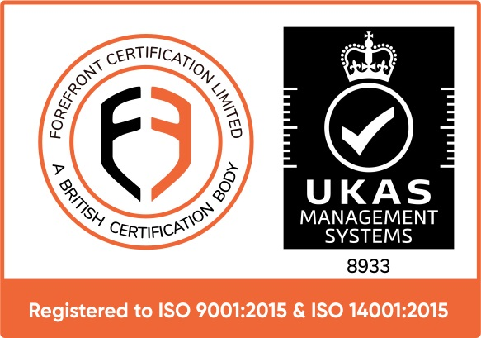
26O2019-QMS & 27O2019-EMS

